# Apply filters to SQL queries

## Project description

Recently some potential security issues were discovered at the organization that involve login attempts and employee machines. I examined the organization’s data in their **employees** and **log_in_attempts** tables by using different SQL filters, retrieved records from datasets and investigated the potential security issues.

## Retrieve after hours failed login attempts

There was a potential security incident that occurred after business hours (after 18:00). All after

hours login attempts that failed need to be investigated.

The following code demonstrates how I created a SQL query to filter for failed login attempts

that occurred after business hours.

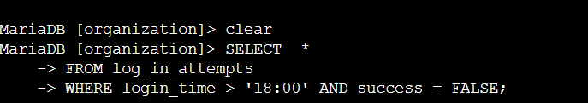

I started by selecting all data from the log_in_attempts table. Then, I used a WHERE clause with an AND operator to filter my results to output only login attempts that occurred after 18:00 and were unsuccessful.

The first condition is login_time > '18:00', which filters for the login attempts that occurred after 18;00. The second condition is success = FALSE, which filters for the failed login attempts.

## 

## 

## 

## Retrieve login attempts on specific dates

A suspicious event occurred on 2022-05-09. Any login activity that happened on 2022-05-09

or on the day before needs to be investigated.

The following code demonstrates how I created a SQL query to filter for login attempts that

occurred on specific dates.

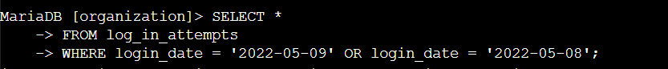

I started by selecting all data from the log_in_attempts table. Then, I used a WHERE clause with an OR operator to filter my results to output only login attempts that occurred on either 2022-05-09 or 2022-05-08. The first condition is login_date = '2022-05-09', which

filters for logins on 2022-05-09. The second condition is login_date = '2022-05-08', which filters for logins on 2022-05-08.

## Retrieve login attempts outside of Mexico

After investigating the organization’s data on login attempts, I believe there is an issue with the

login attempts that occurred outside of Mexico. These login attempts should be investigated.

The following code demonstrates how I created a SQL query to filter for login attempts that occurred outside of Mexico.

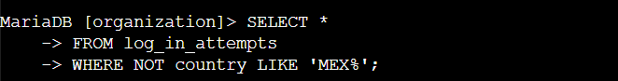

First, I started by selecting all data from the log_in_attempts table. Then, I used a WHERE clause with NOT to filter for countries other than Mexico. I used LIKE with MEX% as the pattern to match because the dataset represents Mexico as MEX and MEXICO. The percentage sign (%) represents any number of unspecified characters when used with LIKE.

## Retrieve employees in Marketing

My team wants to update the computers for certain employees in the Marketing department.

To do this, I have to get information on which employee machines to update.

The following code demonstrates how I created a SQL query to filter for employee machines from employees in the Marketing department in the East building.

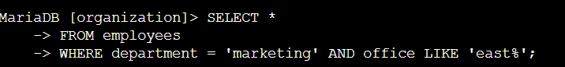

I started by selecting all data from the employees table. Then, I used a WHERE clause with AND to filter for employees who work in the Marketing department and in the East building. I used LIKE with East% as the pattern to match because the data in the office column represents the East building with the specific office number. The first condition is the department = 'Marketing' portion, which filters for employees in the Marketing department. The second condition is the office LIKE 'East%' portion, which filters for employees in the East building.

## Retrieve employees in Finance or Sales

The machines for employees in the Finance and Sales departments also need to be updated.

Since a different security update is needed, I have to get information on employees only from

these two departments.

The following code demonstrates how I created a SQL query to filter for employee machines

from employees in the Finance or Sales departments.

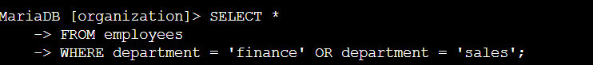

I started by selecting all data from the employees table. Then, I used a WHERE clause with OR to filter for employees who are in the Finance and Sales departments. I used the OR operator instead of AND because I want all employees who are in either department. The

first condition is department = 'Finance', which filters for employees from the Finance department. The second condition is department = 'Sales', which filters for employees from the Sales department.

## 

## 

## 

## Retrieve all employees not in IT

My team needs to make one more security update on employees who are not in the

Information Technology department. To make the update, I first have to get information on

these employees.

The following demonstrates how I created a SQL query to filter for employee machines from

employees not in the Information Technology department.

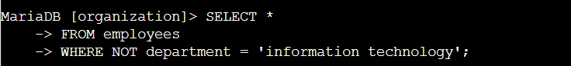

I started by selecting all data from the employees table. Then, I used a WHERE clause with NOT to filter for employees not in this department.

## Summary

I applied filters to SQL queries to get specific information on login attempts and employee

machines. I used two different tables, log_in_attempts and employees. I used the AND,

OR, and NOT operators to filter for the specific information needed for each task. I also used

LIKE and the percentage sign (%) wildcard to filter for patterns.